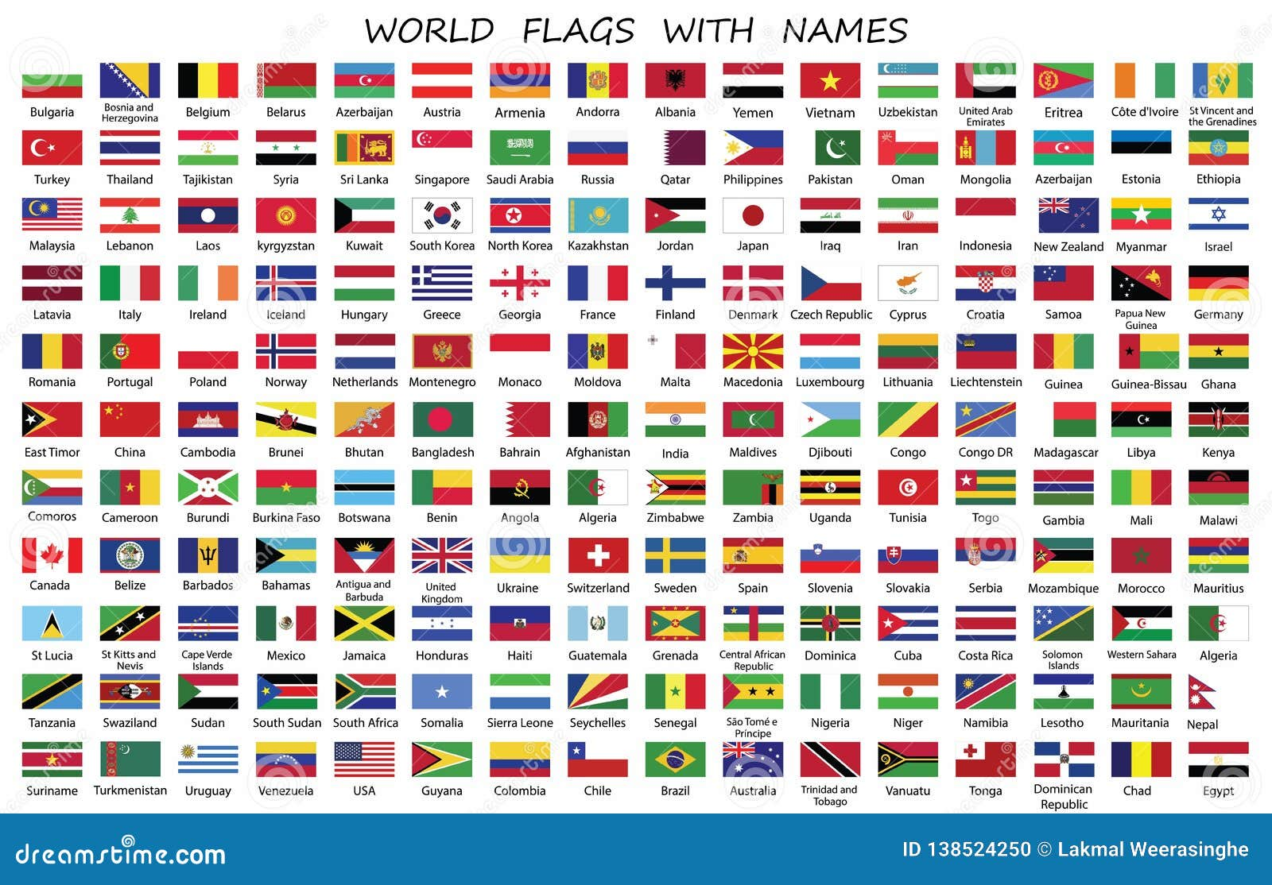

The Forbes List is an annual ranking compiled by Forbes magazine that lists the richest and most influential people or companies in the world. The list includes billionaires, millionaires, famous entrepreneurs, investors, and other successful individuals. In addition, Forbes also publishes lists of companies, industries, and countries based on various criteria such as revenues, assets, profits, and market influence. These lists serve as a benchmark to measure wealth and success in the world of business and finance.

Hello

Hello

Hello world